How to set Weigand
Weigand interface support WG26 and WG34, for Door control board.
Warning: Most control board support WG26. But Haikong’s board only support WG34, such as DS-K2601, DS-K2604.
Step 1: Open Weigand
Open ReaderSoft file path
Double click ReaderSoft.exe logo.
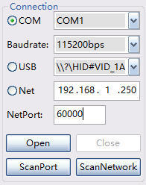, Choose connect port, such as COM, USB or Net(RJ45)
Then click Open button, it will show like this picture
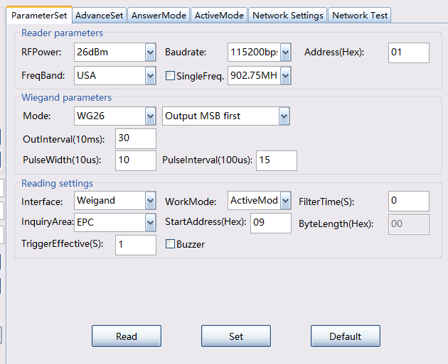

Select interface as Weigand, WorkMode select ActiveMode.
If want to read tag last 3 bytes, set StartAddress as 9. Bytelength is 3
If select WG34, want to read tag last 4 bytes, set StartAddress as 8. Bytelength is 4
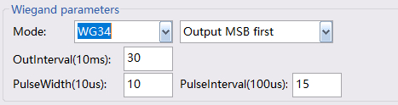
After seting, click set button.
Weigand wire color :
Yellow is WG0
Green is WG1

